Mentoring Leaders within the Circle of Grace

by Herman Moldez 10 April 2024

Nurturing Christlike Leadership in Pastoral Ministry
by H.A. Moldez, A3 / Philippines
In the dynamic landscape of pastoral leadership, the significance of informal mentoring has emerged as a vital component in shaping the character and effectiveness of leaders. While formal and non-formal education programs are expanding and contributing greatly to the development of pastoral leaders, there remains a crucial gap in leader development that informal mentoring aims to bridge.
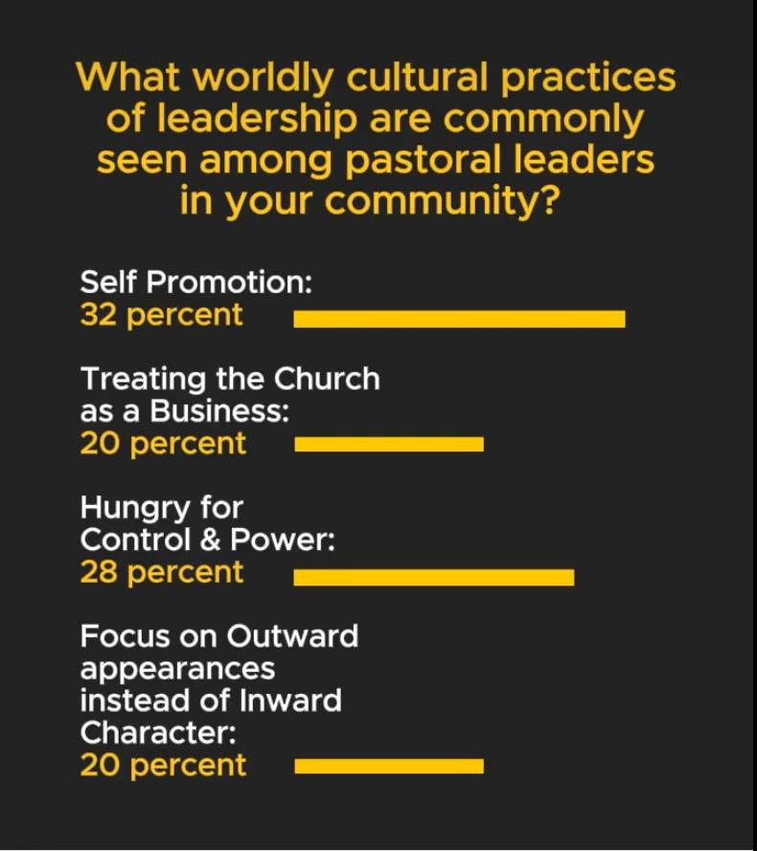
Formal education equips pastoral leaders with biblical and theological knowledge, while non-formal education hones practical ministry skills, enhancing competency in various aspects of ministry. However, amidst these advancements, many pastoral leaders find themselves influenced by prevailing cultural norms that emphasize individualism and autocratic leadership styles.

Trend Toward Worldly Leadership Styles
Across the globe, there is a concerning trend of pastoral leaders mirroring characteristics of tribal chiefs, dictators, corporate CEOs, and even abusive figures. This trend is not new, as even Jesus' disciples aspired to worldly notions of greatness. Yet, Jesus himself challenged these notions, denouncing the pursuit of worldly greatness as incompatible with Kingdom leadership.
In this pursuit of greatness, many pastoral leaders have become adept at building their reputations and acquiring influence, yet they often lack growth in Christlikeness. Consequently, we witness disturbing trends such as the downfall of celebrity pastoral leaders, toxic leadership dynamics, and a growing perception of pastoral ministry as irrelevant in addressing contemporary issues. Moreover, the pressures of ministry often lead to burnout and tempt many pastoral leaders to abandon their calling.

Jesus' Radical Alternative
Jesus Christ presents a radical alternative to the pursuit of worldly greatness, calling leaders to embody humility, holiness, and sacrificial service. Instead of seeking to ascend to positions of power, Christ calls leaders to descend in humility, following his example of self-emptying love. True leadership, therefore, is not about elevating oneself but about serving others with grace and compassion.

Mentoring emerges as a powerful means of cultivating this Christlike leadership paradigm within pastoral ministry. Within the circle of grace formed through mentoring relationships, pastoral leaders are invited to embrace their identity as beloved children of God and to grow into the likeness of Christ. Peer mentoring fosters spiritual formation and accountability, grounding leadership in the transformative power of grace.
As the landscape of pastoral leadership continues to evolve, the need for intentional mentorship within the context of grace becomes increasingly apparent. By embracing the call to lead with humility, holiness, and sacrificial love, pastoral leaders can truly embody the servant leadership model exemplified by Jesus Christ. Through mentoring relationships rooted in grace, leaders are empowered to navigate the complexities of ministry with authenticity, resilience, and a deep commitment to Christlikeness.
Nurturing Christlike Leadership Through Mentoring: A Journey in the Circle of Grace
In the fast-paced world of ministry, where success is often measured by outward appearances rather than inner transformation, the need for authentic mentorship within a circle of grace has never been more critical. True leader development among pastoral leaders must go beyond formal education and practical training to encompass the shaping of character and integrity through informal mentoring relationships.

1. A Safe Place to Trust
In a culture that celebrates outward success and accolades, pastoral leaders are often pressured to prioritize image over authenticity. Yet, Jesus himself condemned the false leaders who sought recognition and status rather than humility and sincerity. Within the confines of success-driven ministry, the temptation to prioritize appearances over integrity can be overwhelming. In such environments, finding a safe space to acknowledge vulnerabilities and struggles without fear of judgment is paramount.

Mentoring within the circle of grace precisely offers that—a sanctuary where pastoral leaders can be transparent about their shortcomings and receive compassionate feedback for growth. Peer mentors provide a supportive environment where leaders can confront their blind spots and embrace accountability without condemnation. It is within this space of trust that true transformation begins, as leaders are encouraged to confront their imperfections and align their lives with the example of Christ.

2. A Shaping Place to Train
In a world dominated by cultural norms and technological advancements, the influence of societal pressures on leadership cannot be overestimated. To remain faithful to the teachings of Jesus amidst these pressures, pastoral leaders require a counter-cultural community of support. Mentors, who model Christlikeness in their lives, play a crucial role in shaping the character and leadership style of emerging leaders.
Mentoring relationships provide opportunities for leaders to observe and learn from the examples of those who embody the values of Jesus. Through shared experiences and wisdom gained over time, mentors impart tacit knowledge that goes beyond mere theoretical understanding. Moreover, mentors motivate and inspire leaders by sharing their own struggles and experiences of God's grace, encouraging resilience and perseverance in the face of challenges.

3. A Sacred Place to Transform
At the heart of spiritual mentoring lies the recognition that true transformation occurs in the presence of the Holy Spirit. While mentors facilitate this process, they ultimately defer to the guidance and work of the Spirit in the lives of those they mentor. Within the sacred space of peer mentoring, leaders engage in spiritual conversations and contemplation, allowing the reality of their human experiences to be met with grace and compassion.
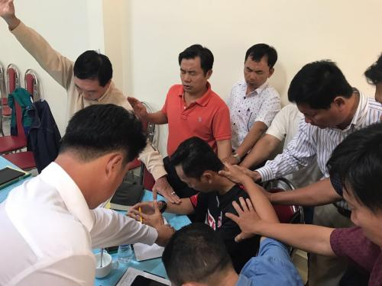
Contemplation, characterized by a deep and loving gaze at the reality of life, enables leaders to embrace their vulnerabilities and recognize the presence of grace in their journey toward Christlikeness. Through the powerlessness of mentors to effect change and the paradox of power in powerlessness, leaders learn to rely on the Holy Spirit for true spiritual growth.
Informal mentoring within the circle of grace offers a transformative journey for pastoral leaders seeking to embody the servant leadership model exemplified by Jesus Christ. As leaders confront cultural pressures, receive feedback for growth, and engage in spiritual contemplation, they are invited to embrace their identity as beloved children of God and live out their calling with humility and integrity. It is through the power of peer mentoring that leaders are equipped to navigate the complexities of ministry and remain faithful to the call to live and lead like Jesus.

Reflection Questions
- What cultural practices of leadership do you observe among pastoral leaders in your community?
- How have godly mentors influenced your journey toward Christlike leadership?
- In what ways will you integrate peer mentoring into your life and ministry moving forward?


Dr. Herman Moldez
Leadership Team, A3/Philippines
A3/Philippines National Director
MentorLink
TOPIC
Pastor Mentoring International Network

More Information
This article was adapted from a presentation for the GPro II Congress:
- Dr. Herman Moldez's impactful presentation resulted in interaction from LeaderServants whose transparent insights and common themes pointed to a shared passion for nurturing Christlike leaders to strengthen the health of Christ's Bride.
Other articles from Herman Moldez:
- The IMPACT of the IMPERFECT
- The Blessing of the Pandemic: God's Deconstruction of My Ministry
- Toward A Deeper Discipleship
- Living Each Day At A Time
- What is your greatest ambition?
Two quick links for your ongoing encouragement:
- If you could not join or would simply enjoy reviewing Dr. Moldez’s “Circle of Grace” talk, watch below or visit this link: https://vimeo.com/919332194/bd46c9b564.
- If you are interested in learning more about mentoring, you may fill in this form to receive additional details about the March 20 virtual gathering of the PMIN network: https://forms.gle/Hq6fcdcUEqkFNuss9

